INDEX

Chapter no | Chapter Title | Page no
1 | Company Profile | 2-5
 | 1.1 Overview of the Organization
 | 1.2 Vision And Mission Of The Organization
 | 1.3 Organization Structure
 | 1.4 Roles and Responsibilities of Personnel in the Organization
 | 1.5 Marketing Performance Overview
2 | ON JOB TRAINING -1[WEB DEVELOPER] | 6-13
 | 2.1 Ability to Apply Skills and Technical Knowledge on OJT1
 | 2.2 Performance on Assigned Tasks and Project
 | 2.3 Extent of Inter’s Ability to Add Value to The Organization
 | 2.4 Team Dynamics
3 | ON JOB TRAINING | 14-17
 | 3.1 Ability to Apply Skills and Technical Knowledge on OJT 2
 | 3.2 Performance on Assigned Tasks and Project
 | 3.3 Extent of Intern’s Ability to Add value to the Organization
4 | USE CASES | 18-
4.1 Use case Developing and Integrating PhaserJs for
InteractiveResume.com
4.2 Use Case Development and Testing of the Interactive
Resume.com

- Overview of the Organization

Arlig Technologies LLP is a global leader in providing AI-powered CRM solutions and custom digital services. As an official Salesforce Implementation Partner, the company operates across India, UAE, and the USA (partnered with INZEKO), offering cutting-edge solutions that empower businesses with tailored services. With expertise in Salesforce consulting, integration, and data migration, Arlig Technologies is committed to driving success through innovation and client-centric solutions

- Vision and Mission of the Organization Vision
To be the most trusted technology partner for businesses worldwide, delivering innovative, scalable, and customer-first solutions through Salesforce and advanced technologies.

Mission
- To empower businesses with tailored digital solutions that enhance productivity, streamline operations, and drive growth.

- To leverage AI, CRM, and cutting-edge technologies to transform businesses into data-driven, efficient enterprises
- To provide industry-specific, innovative, and sustainable solutions while maintaining a client-focused approach.

- Organization Structure
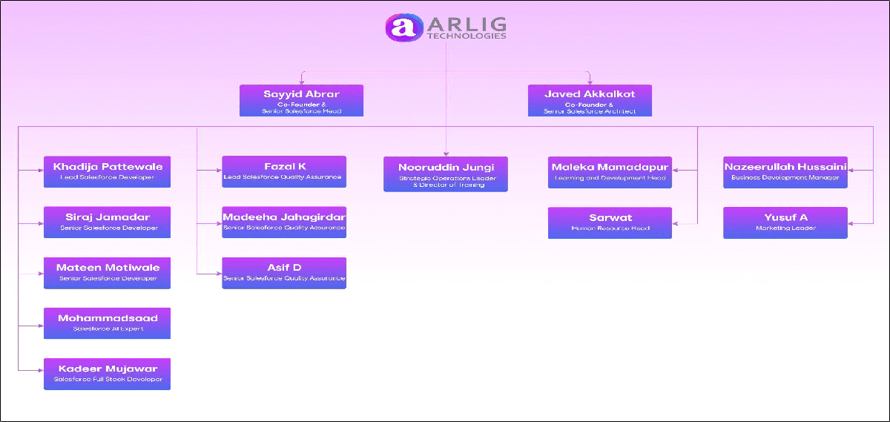

- Roles and Responsibilities of Personnel in the Organization

Arlig Technologies maintains a structured hierarchy with a focus on collaboration and expertise.
- Core Leadership Team:
- Javed Akkalkot – Sr. Salesforce Architect
- Sayyid Abrar – Salesforce Practice Head
- Nooruddin Jungi – Director Training
- Departments:
- Salesforce Consulting & Implementation
- Full-Stack Development
- Customer Support & Training
- Marketing & Sales
- Research & Development

- Global Presence:
- UAE Office: Sharjah Research Technology and Innovation Park
- India Office: Vijayapura & Bengaluru
- USA Partnership: INZEKO
Roles and Responsibilities For interns, roles and responsibilities vary based on the department:

Salesforce Consulting & Development Interns
- Assist in developing Salesforce solutions, including integration and data migration.
- Learn and implement AI-powered CRM tools to streamline business operations.
- Work on real-world client projects under the guidance of certified Salesforce experts.

Full-Stack Development Interns
- Contribute to custom application development projects using modern frameworks and technologies.
- Participate in UI/UX design, backend integration, and testing for seamless user experiences

Data Analysis Interns
- Analyze client business data to derive actionable insights.
- Work on Tableau CRM dashboards to help businesses make data-driven decisions.

Marketing Performance Overview
- Global Reach: Presence in 4 countries with successful client delivery in North

America, Middle East, and Europe.
- Certified Experts: 40+ Salesforce-certified professionals.
- Project Success: Over 100+ successful projects delivered across 10+ industries.
- Industry Specialization: Expertise in sectors like legal, retail, healthcare, and IT.
- Client Testimonials: High client satisfaction with businesses reporting improved operational efficiency, increased productivity, and enhanced revenue growth.

- Salesforce Consulting
- Strategic guidance to optimize Salesforce ROI.
- Salesforce Implementation
- Seamless setup and customization of Salesforce to match business requirements.
- Integration Services
- Connecting Salesforce with existing enterprise systems for smooth operations.
- Data Migration
- Securely transitioning business data into Salesforce.
- Custom CRM Solutions
- Industry-specific solutions, e.g., legal case management, inventory optimization, and revenue tracking.
- Analytics & Dashboards
- Tableau CRM dashboards for real-time data visualization and performance tracking

CHAPTER-2

- Ability to Apply Skills and Technical Knowledge on OJT1

During my internship time period at Arlig Technologies ,I had got the opportunity To apply my skills and technical Knowledge gained thorugh this period of time. This report provides and overview of my performance on the assigned Tasks and My project .

Tasks : Frontend Development using HTML, CSS, JavaScript, and React.
Designed a responsive layout to ensure compatibility across devices.Implemented animations and interactive elements using JavaScript.

Project : Drawing upon my understanding of web development technologies such as HTML, CSS, and JavaScript, as well as the Phaser.js framework, I was able to design and implement the pages effectively. This involved creating an interactive, animated interface where users can navigate through my resume in a dynamic and engaging way.

- Performance on Assigned Task and Project

During my internship, I took on various responsibilities that required both technical expertise and problem-solving skills. One of my key contributions was working on Animated Interaactive Resume where I was involved in developing essential components such as the Animations, Game Elements for the platform.

To ensure a smooth workflow, I carefully analyzed project requirements and broke tasks into structured steps. I prioritized features based on their importance and dependencies, making the development process efficient and organized. Collaborating closely with my mentors and team members, I actively participated in discussions, took feedback constructively, and refined my work accordingly.

Before starting the development phase, our team thoroughly reviewed the Figma designs provided for the project. The designs followed a clean and modern aesthetic, with intuitive navigation and a seamless user experience. I ensured that the final implementation aligned with these design principles while adhering to coding best practices.

By maintaining clear communication, adhering to deadlines, and focusing on quality, I was able to contribute effectively to the project's success. My ability to adapt, learn, and collaborate played a significant role in the timely completion of tasks and in earning the trust of my colleagues.

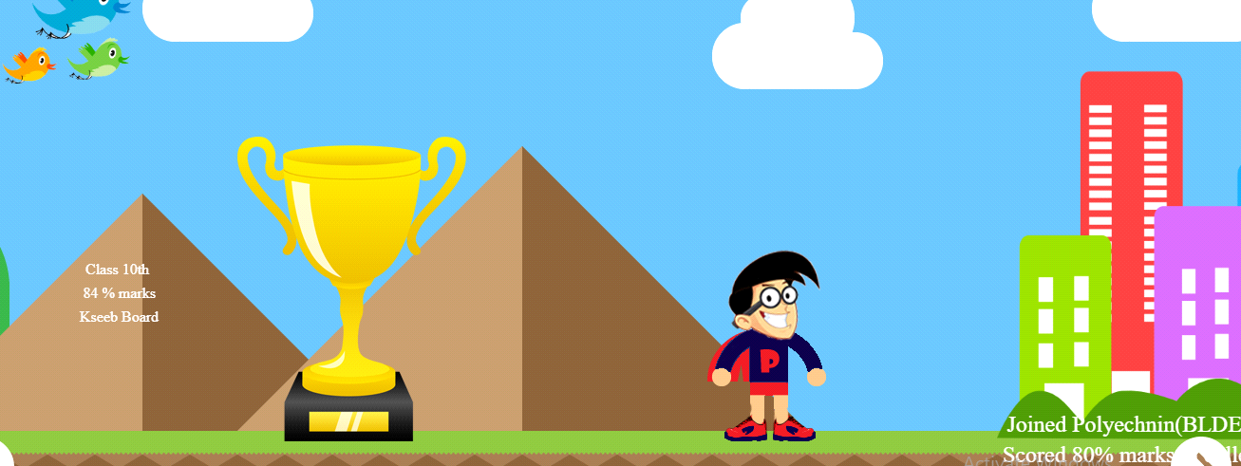

- Main Functionality
1.Portfolio Showcase :- Showcases his achievements, projects, and contributions in the field of software development and education.
2.Connenctions and Links
Contains insightful links related to Social Media, and Github.
Helps website visitors to and stay connected and updated
3.Projects & Open-Source Contributions

Features projects and open-source contributions.
Provides links to GitHub repositories or live projects for reference.
Contact & Social Media Links

Offers ways to connect via LinkedIn, Twitter, or other platforms.
UI/UX Design & Navigation

Clean, modern, and responsive design for a seamless user experience.
Easy-to-navigate sections, allowing users to quickly find relevant information.
Structure Breakdown of Project

1. Game Canvas (Main Display Area)
The entire resume is rendered inside a Phaser-powered canvas.
Uses animations and interactions instead of a traditional static layout.
2. Scenes (Sections of the Resume)
Phaser divides the resume into different interactive scenes, such as:

Preload Scene – Loads assets like background images, animations, and text styles.
Intro Scene – Displays Prateek’s name, designation, and a welcome message.
About Scene – Interactive presentation of his background, skills, and experience.
Projects Scene – Showcases projects with clickable elements.
Courses & Contributions Scene – Displays courses and open-source work.
Contact Scene – Provides social media links and ways to connect.

3. Interactive Elements (User Engagement Features)
Clickable Buttons / Icons – Navigate between different sections of the resume.
Animated Transitions – Sections slide in or fade for a smooth experience.
Hover Effects – Highlight details dynamically when hovered over.
Parallax Effects – Background moves slightly to create depth.

4. Physics & Motion Effects
Smooth scrolling or object animations using Phaser’s Tween Manager.
Possible use of drag-and-drop interactions for a unique experience.

5. UI Elements (Resume Content Display)
Text Display – Phaser's text rendering to show experience, skills, and projects.
Icons / Logos – Represent different skills or platforms like GitHub, LinkedIn, etc.
Timeline Animation – Experience or education might appear step by step.

6. Media & Assets
Uses images, SVGs, or sprite-based assets for visual appeal.
Might include background music or sound effects (if applicable).

7. Navigation & User Flow
Users navigate the resume by:
Clicking buttons.
Using arrow keys or scrolling.
Interacting with animated elements.

Functionality of the Page

1. Interactive Resume Navigation
- Users can navigate through different sections of the resume using clicks, keyboard keys, or scrolling.
- Smooth animations and transitions guide the user through different parts of the resume.
2. Visual Representation of Work & Experience
- Instead of a static page, the resume presents experience, projects, and skills dynamically with visual effects.
- Information is displayed in a structured, interactive way, making it engaging.
3. Animated Career Timeline
- Work experience and education appear as step-by-step animations or transitions.
- Possible parallax effects for depth and smooth flow.
4. Project Showcase
- Users can click on project icons or sections to view details.
- May include animated previews, descriptions, and external links to GitHub or live projects.
5. Skill & Course Highlights
- Interactive representation of technical skills and expertise.
- Clicking or hovering may reveal more details.
6. Contact & Social Media Integration
- Clickable LinkedIn, GitHub, Twitter, and Email buttons for easy connection.
- Possibly includes an email form or direct messaging feature.
7. Smooth UI & Game-Like Feel
- Uses Phaser for smooth animations, transitions, and interactions.
- Engages visitors with a fun, game-like user experience instead of a boring static page.
Styling & Animations
- 1. Styling in Phaser (Visual Design Elements)
- Unlike CSS in regular websites, Phaser uses a game-like rendering engine. The styling involves:

- A. Background & UI Design
- Custom Backgrounds:
- Static or parallax backgrounds for depth effects.
- Textured or animated gradients for a modern look.
- UI Components:
- Sprites and Buttons for navigation (instead of HTML buttons).
- Custom fonts for text (using WebFonts or Bitmap Fonts).
- B. Text Styling
- Uses Phaser's Text API to create styled text:
- this.add.text(100, 100, "Welcome to My Resume!", {
- fontFamily: "Arial",
- fontSize: "32px",
- color: "#ffffff",
- align: "center"
- });
- Can have effects like:
- Glowing text (using shadows).
- Typing effect (text appearing letter by letter).
- 2. Animations & Motion Effects
- Phaser provides powerful animation tools through Tweening, Sprite Sheets, and Physics.

- A. Scene Transitions (Smooth Navigation)
- Sections of the resume slide in, fade, or scale up/down when moving between them.
- Example of a fade-in effect when entering a new section:
- this.tweens.add({
- targets: this.cameras.main,
- alpha: { from: 0, to: 1 },
- duration: 1000,
- ease: 'Power2'
- });
- B. Character / Avatar Animation (If Present)
- If an avatar or icon exists, it might have:
- Idle animation (subtle bouncing, blinking).
- Hover interactions (scaling up, glowing).
- Walking or movement effects based on user navigation.
- C. Parallax Effects (Depth & Layering)
- Background elements move at different speeds when scrolling or navigating.
- Creates a 3D-like depth effect for better user experience.
- D. Button & Element Hover Effects
- Buttons and UI elements might scale, change color, or pulse when hovered.
- this.tweens.add({
- targets: myButton,
- scaleX: 1.1,
- scaleY: 1.1,
- duration: 200,
- yoyo: true
- });
Interactive Icons & Links
- Social media icons and project links shake, glow, or pop when hovered over.
- Uses tweens to rotate, pulse, or bounce clickable elements.
- 3. Physics & Motion
- Uses Phaser's Arcade Physics for smooth dragging, dropping, or floating effects.
- Example: A floating effect on an element:
- this.tweens.add({
- targets: resumeIcon,
- y: resumeIcon.y - 10,
- duration: 800,
- ease: "Sine.easeInOut",
- yoyo: true,
- repeat: -1 });
Extent of Intern’s Ability to Add Value to the Organization

As an intern, my primary goal was to add value to the organization through my contributions and efforts. The development of the Front End Development for InteractiveResume.com provided a tangible example of how I was able to fulfill this goal.
In addition to developing the page itself, I was also tasked with testing its functionality to ensure a seamless user experience. This involved conducting thorough testing, including unit testing, integration testing, and user acceptance testing, to identify and address any bugs or issues before the project is in use. By taking ownership of the testing process and ensuring the reliability and stability of the Project , I helped to enhance the overall quality of the InteractiveResume.com website and improve the overall componenets of the project.

- Team Dynamics
Working within a collaborative team environment was instrumental in the success of the project. I had the opportunity to collaborate with talented individuals from diverse backgrounds, including developers, designers, and project managers.

My teammates provided valuable support and feedback throughout the development process, fostering a culture of continuous learning and improvement. Through regular standup meetings, code reviews, and collaborative discussions, we ensured alignment with project goals and fostered a sense of camaraderie and shared responsibility.

CHAPTER-3

OJT(DEVELOPER)

- Ability To Apply Skills and Technical Knowledge on OTJ 2

During the On-Job Training (OJT2) phase of my internship, I had the opportunity to apply my skills and technical knowledge in a real-world development environment. My primary focus was on frontend development . I worked on building responsive web pages, styling components, and implementing interactive UI elements. Additionally, I collaborated with my team to troubleshoot design issues and enhance user experience. This hands-on experience allowed me to improve my understanding of React components, state management, and best practices in frontend development, strengthening my ability to create functional and visually appealing web applications.

- Understanding Problem Statement and Requirements :
- I started by analyzing the project requirements and understanding the core functionalities of the web application I was working on. This involved reviewing design mockups, user flows, and expected interactions to ensure a seamless user experience.
- Using my knowledge of HTML, CSS, JavaScript, and React, Phaser I identified key areas that needed development, such as responsive layouts, dynamic content rendering, and interactive UI elements.
- Each component was carefully planned, ensuring proper structuring, styling, and functionality. I focused on optimizing the user interface for accessibility and performance, ensuring a smooth and engaging experience across different devices and screen sizes.
- Utilizing Developer Tools and FrameWork:

I leveraged various developer tools and frameworks to streamline the front-end development process and enhance efficiency. This included using browser developer tools to inspect elements, debug issues, and optimize performance.
For developing and to add game like elements in the Project i had used PhaserJs(Javascript framework).
Styling and responsiveness, I utilized CSS frameworks like Bootstrap and Tailwind CSS, ensuring a consistent and visually appealing design. In React, I worked with state management libraries and component-based architecture to build dynamic and interactive user interfaces efficiently.
I also used version control systems like Git for collaboration and code management, ensuring smooth development workflows and maintaining project integrity.

- Collaboration and Communication:

Throughout the development process, I collaborated closely with designers, backend developers, and other stakeholders to ensure the front-end aligned with project goals and user requirements. Regular discussions and feedback sessions helped refine UI components, improve user experience, and address any design inconsistencies.

- Effective communication allowed me to understand requirements clearly, seek clarifications when needed, and implement changes efficiently. Working in a team environment also enhanced my problem-solving skills and adaptability in a professional setting.
- Performance on Assigned Tasks and Project

My performance on the assigned front-end development tasks was marked by diligence, precision, and a user-focused approach. I systematically analyzed the project requirements, breaking down UI components into manageable sections and prioritizing them based on usability and functionality.
I ensured that the web pages were visually appealing, responsive, and interactive, aligning with the design specifications. By adhering to best coding practices and optimizing performance, I contributed to creating a seamless user experience while meeting project deadlines effectively.

- Thorough in Test Case Development

I ensured that each aspect of the front-end development covered a wide range of scenarios, including typical user interactions and edge cases, to enhance the application's usability and responsiveness.
By adhering to best practices in UI development, such as maintaining clean code, optimizing performance, and ensuring cross-browser compatibility, I contributed to the overall quality of the project. This approach helped create a seamless and reliable user experience while improving the application's efficiency and accessibility.

- Adaptability and Flexibility

I demonstrated adaptability and flexibility in responding to changes and updates in project requirements. As the project evolved, I adjusted the front-end components accordingly, ensuring that the UI remained functional, visually consistent, and aligned with the latest design specifications.
- Extent of Intern’s Ability to Add Values To The Organization

Through my internship, I was able to add significant value to the organization by contributing to the front-end development of web applications. By building responsive and interactive UI components using HTML, CSS, JavaScript, and React, helping to enhance the user experience and visual appeal of the project.
- Abilities to implement clean, efficient, and maintainable code ensured smooth performance and usability. Additionally, by collaborating with the team and addressing feedback effectively, I contributed to the overall efficiency and success of the development process.
- Key Contributions:

Played a crucial role in developing a responsive and user-friendly interface for the project, ensuring seamless interaction and an engaging user experience.Implemented modern front-end technologies, frameworks, and best practices to enhance website performance and accessibility.Worked closely with UI/UX designers to translate design mockups into fully functional web pages while maintaining design consistency.Optimized front-end code for faster load times, improved responsiveness, and cross-browser compatibility.Integrated API endpoints to dynamically fetch and display real-time data, improving overall functionality.Ensured accessibility compliance by implementing proper semantic HTML, ARIA attributes, and keyboard navigation support.Conducted rigorous testing of UI components to identify and resolve bugs, enhancing the stability of the application.Collaborated with backend developers to ensure seamless integration between front-end and backend systems.Contributed to code documentation and maintained clean, reusable, and scalable code for future improvements.
CHAPTER 4
- UseCase Developing and Integration for INTERACTIVE RESUME
- Actor: Intern (Frontend Developer)

Development Process
A. Planning & Design
Understanding Requirements:
The goal was to create a visually appealing, interactive resume.
Wireframing & UI Design:
The initial structure was designed using Figma (or similar tools).
Decided on visual elements, animations, and user interactions.
B. Implementing Phaser for the Resume
Project Setup:
Used Phaser 3 as the core framework.
Set up the development environment with JavaScript or TypeScript.
Scene Creation:
Divided the resume into different scenes (sections) for easy navigation.
Examples:
Intro Scene: Welcome animation and introduction.
Skills Scene: Animated skill icons.
Projects Scene: Clickable projects with details.
Contact Scene: Interactive social media links.
Adding Interactivity:
Used Phaser’s event listeners for clicks, keypresses, and hover effects.
Implemented animated transitions between different sections.
C. Styling and Animation
Custom Fonts & Text Effects
Used Phaser’s text rendering to create styled headers and descriptions.
Implemented effects like fade-ins, scaling, and glowing text.
Smooth Animations
Created scene transitions, parallax scrolling, and sprite animations.
Used tweens for smooth UI movements.
Physics & Motion
Applied lightweight physics effects for elements like floating icons.

Post-Condition of the Phaser-Based Interactive Resume Development
The successful completion of the Phaser-based interactive resume website (www.InteractiveResume.com) resulted in several key outcomes. These outcomes ensure that the project meets its intended objectives and delivers a seamless, engaging experience for users.

1. Functional Completion
All sections of the resume, including Introduction, Skills, Projects, Experience, and Contact, are properly structured and accessible.
Interactive elements, animations, and transitions function smoothly without lag or glitches.
The navigation system effectively guides users through the resume in an intuitive manner.
2. Performance Optimization
The website loads quickly, with optimized assets to ensure smooth animations and interactions.
Phaser’s rendering engine efficiently manages scene transitions and effects without causing performance issues.
The project is tested on multiple browsers to ensure compatibility and responsiveness.
3. Deployment & Accessibility
The website is successfully deployed and accessible via its live domain.
External links to GitHub, LinkedIn, and social media profiles are correctly integrated and functional.
The resume maintains a professional yet engaging user experience across different devices.
4. User Engagement & Interactivity
Visitors can interact with the resume in a way that enhances engagement compared to traditional text-based resumes.
Animations, hover effects, and clickable elements create an immersive experience.
The interactive design encourages users to explore different sections rather than simply scrolling through static content.
5. Maintenance & Scalability
The project is structured for easy updates, allowing new skills, projects, or experiences to be added without significant redevelopment.
Code is well-documented, making future enhancements and debugging easier.
Final Conclusion
The post-condition of the project ensures that the interactive resume is fully functional, well-optimized, user-friendly, and ready for real-world usage. The project successfully demonstrates the power of Phaser in creating engaging, game-like web experiences that stand out from traditional resumes.

